Too many times we see the Turbine valves seats not being restored or
maintained properly. We have at T & W Valve developed a method to restore your turbine valves seats in less than 7 days typically, with a guaranteed 100% blue.

We bring a mobile machine shop to ensure an accurate seat restore tool as every seat is different, with this mobile machine shop we can also support all other turbine machining and welding needs, working alongside the turbine general.

In addition, we have assembled a team that can replace a damaged seat to include, machining, welding, NDT and heat treating. We can also weld, machine and restore your integral seats ( GE, IC valves, and GV )

Our services, delivered through our Owensboro, Kentucky repair center, as well as through plant-site operations, are all staffed by fully qualified, highly proficient technicians and engineers.

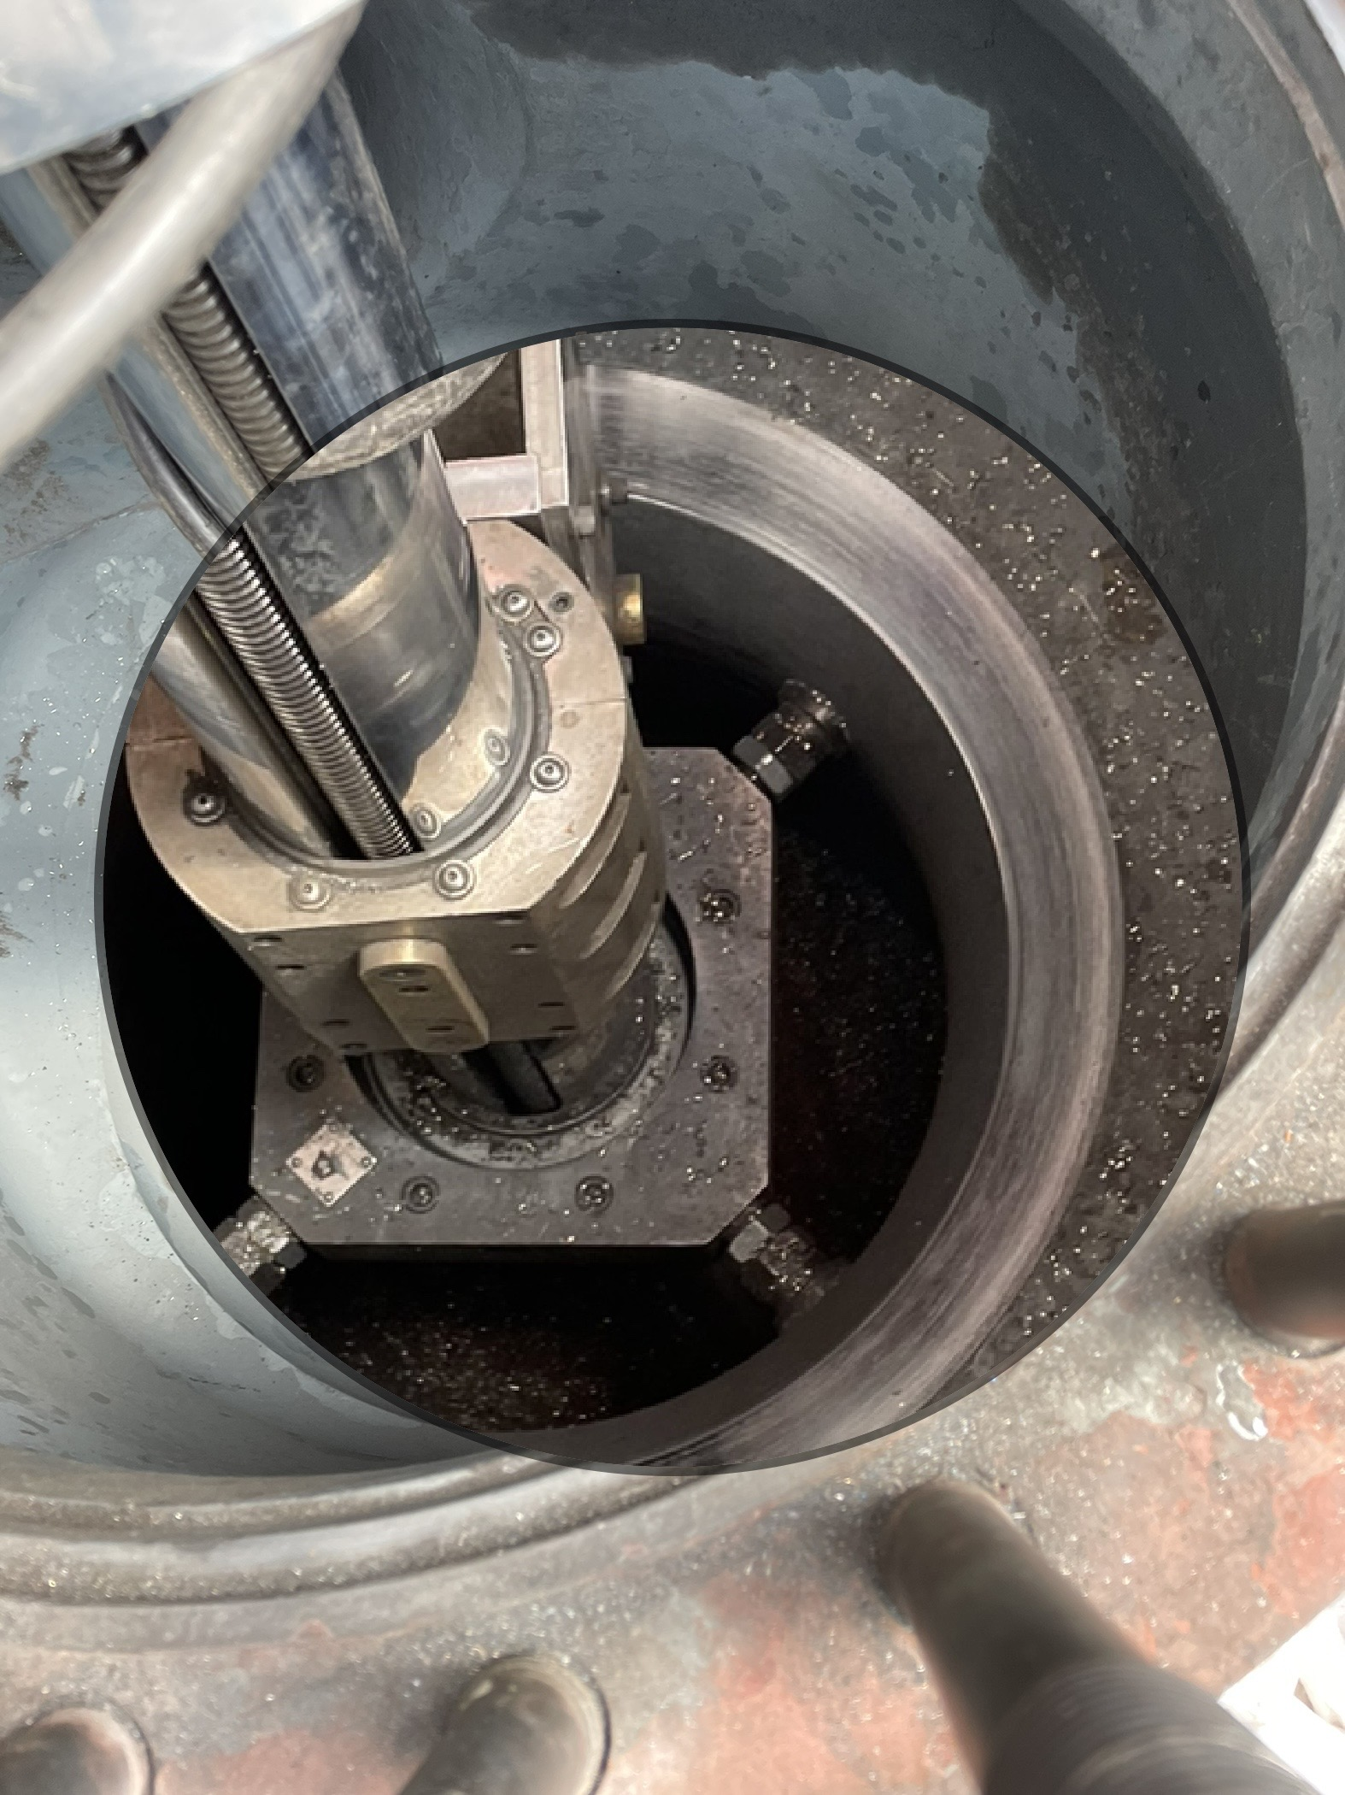

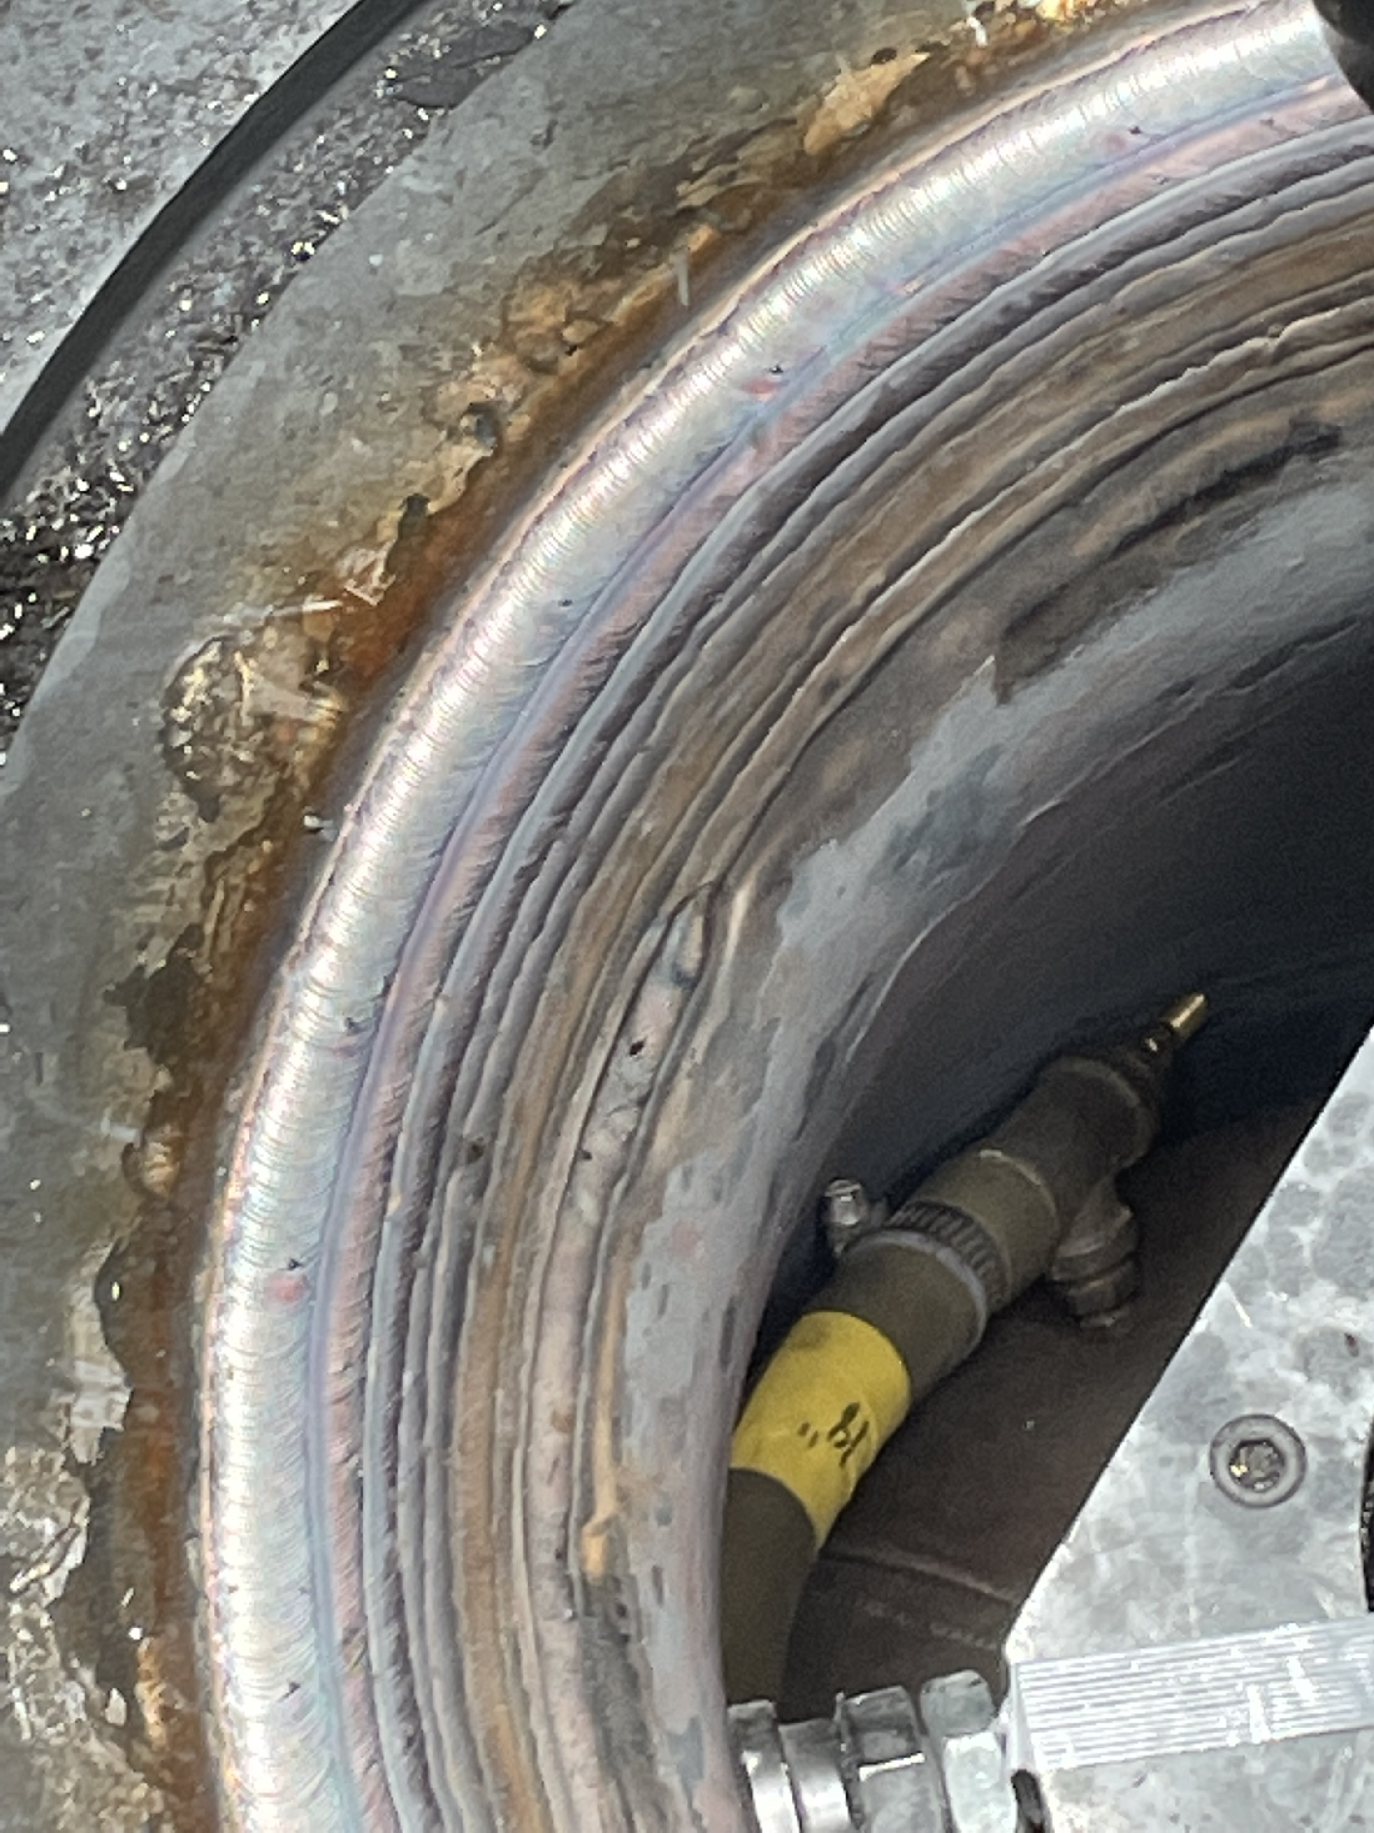

T & W Valve & Machine Co., Inc.
Turbine Valve Repair Services
- Westinghouse
- Throttle Valve
- Governor Valve
- Intercept
- Reheat Stop
- General Electric
- Toshiba
- MSIV
- Combined IV / RS
- Throttle Valve.
- General
- BFP Valves
- Stud Removal
- Seat Replacement
- Seat Restoration
- Coupling Bolts
- Alignment Keys

T & W Valve & Machine Company, Inc.
2501 Grimes Avenue ● Owensboro, Kentucky 42303
PHONE: (270) 683-1995 ● FAX: (270) 683-1065
For a comprehensive and customized explanation of our
services and capabilities, please call us today at (270) 683-1995.

